RMS Value of a Periodic Waveform

The RMS value of a set of values (or a continuous-time waveform) is the square root of the arithmetic mean (average) of the squares of the original values (or the square of the function that defines the continuous waveform).
In the case of a set of n values , the RMS value is given by this formula:
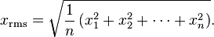
The corresponding formula for a continuous function (or waveform) f(t) defined over the interval is
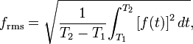
The RMS over all time of a periodic function is equal to the RMS of one period of the function.

RMS Value of a Square Wave

Figure 1 illustrates the plot of a square wave whose amplitude is A and whose period is T. 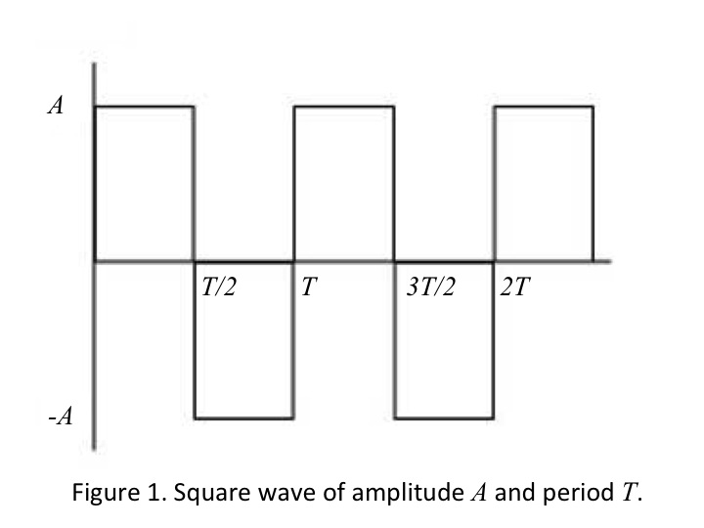
In order to compute the RMS value of the square wave, we begin by squaring the function. When we do this, we obtain the result shown in
Figure 2.
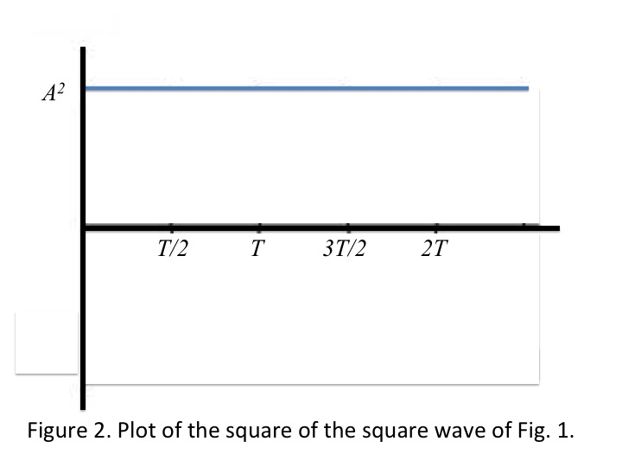
We find the RMS value by integrating the function shown in Fig. 2 over one period and taking the square root of the result. The steps are shown below.

$RMS Value=\sqrt{\frac{1}{T}\int_{0}^{T}{A^{2} dt}}$

$RMS Value=\sqrt{\frac{1}{T} (A^{2} T)}$
$RMS Value= \sqrt{A^{2}}$
$RMS Value=A$

So we find the RMS value of a square wave is equal to the amplitude of the square wave.

RMS Value of a Sinusoid

Figure 3 shows the plot of a sinusoidally varying waveform, $A\cos\left(πx\right).$
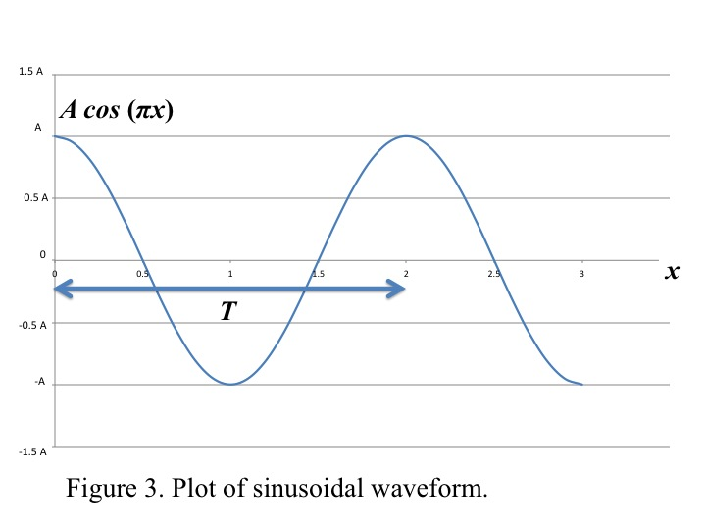
This sinusoid has an amplitude of A and a period of 2.

If we wish to find the RMS value of this waveform, we repeat the steps we used to find the RMS value of the square wave. First we square the waveform to produce the function ${\left(A cos⁡(πx)\right)}^{2}$. Figure 4 shows a plot of this function.
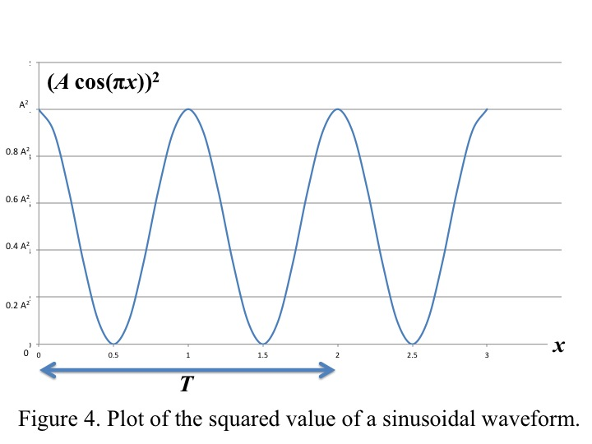
At this point, we recall a formula from trigonometry.

${\left(A cos⁡(πx\right)}^{2}=\frac{A^{2}}{2}+\frac{A^{2}}{2} cos⁡(2πx)$

The RMS value of the sinusoidal function can be expressed as

$RMS value= \sqrt{\frac{1}{2} \int_{0}^{2}{\left(\frac{A^{2}}{2}+ \frac{A^{2}}{2} cos⁡(2πx\right) dx}}$

Notice that we have replaced T with its value, 2. The calculation of the RMS value proceeds as follows. Because we have the integral of a sum, we separate the original integral into two integrals.

$RMS value= \sqrt{\frac{1}{2} \int_{0}^{2}{\frac{A^{2}}{2} dx +\frac{1}{2}\int_{0}^{2}{\frac{A^{2}}{2}\cos\left(2πx\right)dx}}}$

Integrating the function $cos⁡(2πx)$ over two complete periods of the function as represented by the interval [0, 2] yields the result of 0.

$\int_{0}^{2}{\cos\left(2πx\right)dx=0}$

Thus, we are left with the simplified expression,

$RMS value= \sqrt{\frac{1}{2} \int_{0}^{2}{\frac{A^{2}}{2} dx}}$

$RMS value=\sqrt{\frac{1}{2} \frac{A^{2}(2-0)}{2}}$

$RMS value= \sqrt{\frac{A^{2}}{2}}$

$RMS value=\frac{A}{\sqrt{2}}= \frac{\sqrt{2}}{2} A$

Similar results can be found for all other sinuosoidal waveforms of amplitude A. We conclude that the RMS value for any sinusoid of amplitude A is the ratio of its amplitude over the square root of 2.

