**Determining the Acceleration of a Rocket by Use of the Product Rule**

Let us consider a rocket that is travelling through outer space. For the sake of simplicity, we consider the rocket to be sufficiently far away from all planets and other objects so that it may be considered as an isolated system with no external forces working upon it.

The rocket itself can be thought of as a system consisting of the outer shell of the rocket along with the fuel which is contained within the casing of the rocket as shown in the picture below.

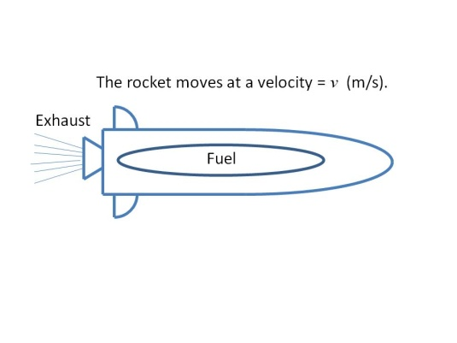

Let us denote the mass of the rocket as *m* (kg) and the velocity of the rocket as *v* (m/s). In physics, you will learn that the ***momentum*** of an object (*p*) is the product of its mass with its velocity.

 (kg-m/s)

When the fuel within the rocket is burned, exhaust gases are produced that leave the rocket through the nozzle. Thus, the mass of the system consisting of the rocket and the fuel it carries will decrease. We can state this mathematically as



In physics, Newton’s second law of motion says that the force acting upon a system is equal to the time rate of change of momentum. If we let F represent the force acting upon the rocket at the time t, then


\begin{align}
F = \frac{dp}{dt}.
\end{align}
 

We may substitute *mv* for *p* in this equation. This produces the equation


\begin{align}
F = \frac{d}{dt}\left( mv \right),
\end{align}
 

and we can now apply the product rule for the derivative.

Application of the product rule gives


\begin{align}
F = v\frac{dm}{dt} + m\frac{dv}{dt}.
\end{align}
 

The acceleration, *a*, is defined as the time rate change of velocity. Thus

.

We can substitute this into the equation above to yield


\begin{align}
F = v\frac{dm}{dt} + ma.
\end{align}
 

Solving for the acceleration becomes a matter of algebra,


\begin{align}
a= \frac{F - v\frac{dm}{dt}}{m}.
\end{align}
 

Since the rocket is losing mass, the term  is negative. At the same time, the velocity is positive. The term is therefore positive.

Because the rocket is traveling in outer space with no external forces acting upon it, the term *F* is 0. We substitute 0 in for *F*. So we conclude the acceleration of the rocket will be

,  are the units of acceleration.

We conclude that expelling the spent gas from the rocket and thus changing mass term results in increased acceleration.