Application of the Integral (Work Required to Compress a Nonlinear Spring)

Springs are fundamental mechanical components which form the basis of many mechanical systems. A spring can be defined to be an elastic member that exerts a resisting force when its shape is compressed.

Suppose that one side of a spring is fixed in its location. When a force F (measured in Newtons) is applied to the other side of the spring, the overall length of the spring will be reduced. The amount of change in the length of the spring is called the displacement. The displacement is denoted by the variable, x. Figure 1 illustrates this situation.
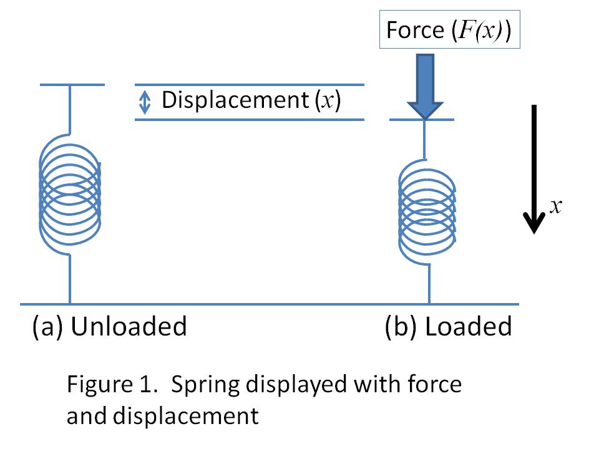
Let us suppose that the spring considered here be what is known as a nonlinear spring. Figure 2 shows a picture of a nonlinear spring.
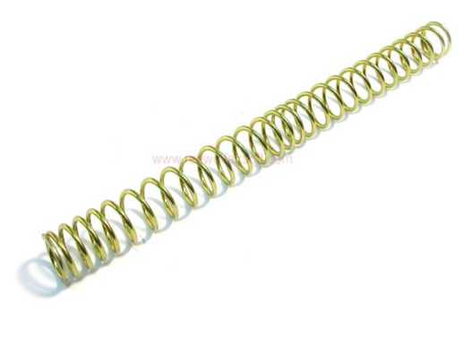
Figure 2. Picture of nonlinear spring.

For a nonlinear spring, we know that there is a nonlinear relationship between the force (F(x)) and the displacement (x).

In order to gain a better understanding of the spring, a technician is directed to collect some data relating the Force and the Displacement. Different forces are applied to the spring and measurements of the corresponding displacements are recorded in Table 1 below.

x | 0 | 0.05 | 0.1 | 0.15 | 0.2 | 0.25
F(x) | 0 | 4 | 17 | 38 | 68 | 106

Table 1. Measurements of displacement for different values of force.

We may sketch a plot of the Force as a function of displacement. Figure 3 shows such a sketch with the data points shown in red. From the sketch, it is clear that there is a nonlinear relationship between force and displacement.
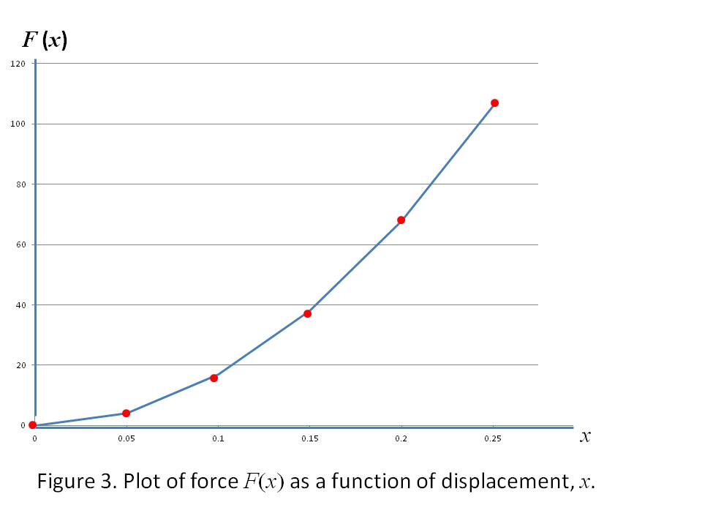
Problem Statement: Determine an estimate for the work that is performed during the process of compressing the nonlinear spring 0.25 m.

Solution: Work (U) is performed whenever a spring is compressed. This is so because the spring exerts a compressive force that resists the Force applied to the spring.

We can express the amount of work (dU) that is expended in compressing a nonlinear spring by a displacement (dx) as a product. Stated mathematically, this product is

We can use this piece of information to help solve our problem. We can estimate the amount of work that it takes to displace the spring by 0.25 meters by making use of the data that was collected. To begin, we observe that the data was taken so that consecutive values of the displacement differ by an amount (0.05 m). This value is analogous to the value dx in the formula above. Suppose we take our first measurement for force (0 N) and multiply it by the value for dx. The product represents an estimate for the amount of work that is required to displace the spring 0.05 m. Now, let us proceed to take our second measurement of force (4 N) and multiply it by dx. This yields a product of 2 N-m. This is analogous to the area of the corresponding rectangular strip shown in Figure 4.
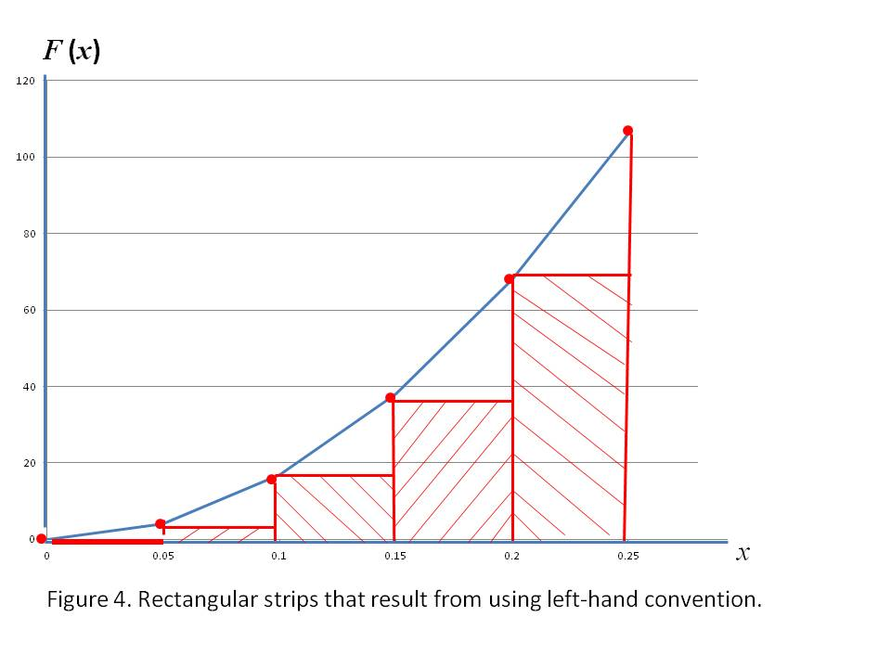
We add it to the first product we computed and obtain 2 N-m. This represents the amount of work it takes to compress the spring 0.1 m. We repeat this process, each time multiplying the value for F shown in the Table by the value for dx and adding the product to the previous result. For the sake of later comparison, we say that this approach utilizes the “left-hand” convention. This is so because the height of each of the rectangular strips in Figure 4 corresponds to the left-hand data point. This creates an estimate for the amount of work needed to compress the nonlinear spring 0.25 m that can be expressed as follows:

$$U=\left(0×0.05\right)+\left(4×0.05\right)+\left(17×0.05\right)+\left(38×0.05\right)+\left(68×0.05\right)=6.35 (N-m)$$

Clearly, the above expression could be re-written as

$$U=\left(0+4+17+38+68\right)×0.05=6.35 (N-m)$$

Computationally, the second expression is usually preferred.

Because the force increases with increasing values of displacement, the estimate obtained 6.35 (N-m) is a lower bound on the amount of work performed. We can establish an upper bound on the estimate by slightly modifying our approach. Here, we will make use of right-hand endpoints on each interval. This approach is illustrated in Figure 5.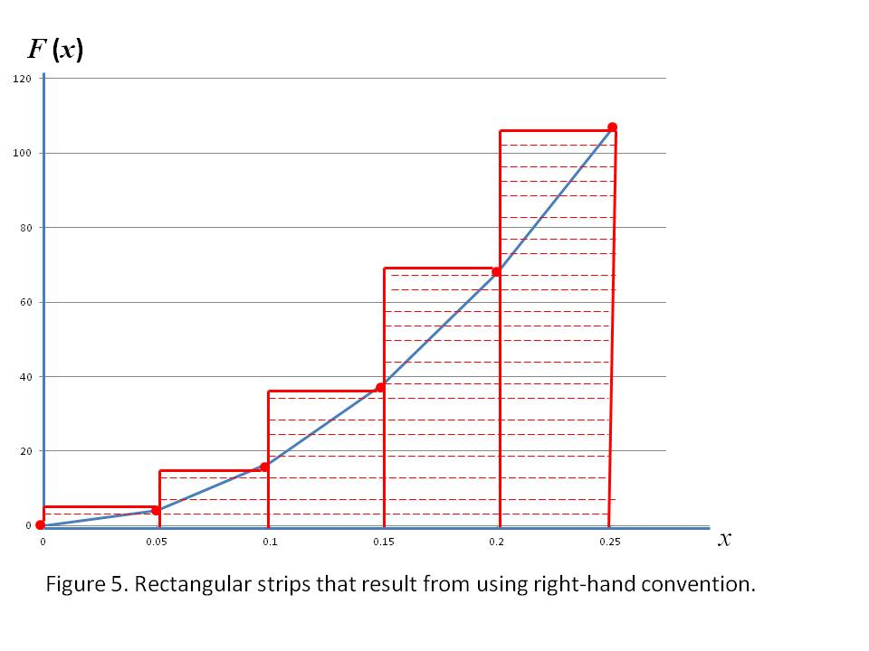

$$U=\left(4×0.05\right)+\left(17×0.05\right)+\left(38×0.05\right)+\left(68×0.05\right)+\left(106×0.05\right)=11.65 (N-m)$$

As was the case before, this estimate may have been expressed as

$$U=\left(4+17+38+68+106\right)×0.05=11.65 (N-m)$$

We observe that these two estimates are quite a bit apart. In order to get a better estimate, we could obtain more data. Increasing the number of data points and decreasing the width of the intervals (dx), we can obtain an improved estimate. Thus, the technician was instructed to collect more data. Specifically, the technician takes twice as much data as before. This data is shown in Table 2.

d | 0 | 0.025 | 0.05 | 0.075 | 0.1 | 0.125 | 0.15 | 0.175 | 0.2 | 0.225 | 0.25
F(d) | 0 | 1 | 4 | 12 | 17 | 26 | 38 | 50 | 68 | 84 | 106

Using this data, we can determine a lower bound on the Work needed to compress the spring using the formula below.

$$U=\left(0+1+4+12+17+26+38+50+68+84\right)×0.025=7.5 (N-m)$$

Similarly an upper bound on the amount of Work can be expressed as
$$U=\left(1+4+12+17+26+38+50+68+84+106\right)×0.025=10.15 (N-m)$$

Taking into account more data has produced bounds that are indeed closer together. This is, indeed, what we expected.

To obtain the exact amount of Work needed to compress the spring 0.25 m, we would have to take an infinite amount of data.

