**Implicit Differentiation: Orbital Mechanics**

In a far away galaxy, there exists a star. The star has a single planet named Tralfamadore. There are two interesting facts that exist with regard to the orbit of Tralfamadore. To begin, the orbit is circular with a radius of 5,000,000 km. Secondly, the orbit of Tralfamadore is planar.

Using what we know about the orbit of Tralfamadore, we can develop the sketch of its orbit as shown below.

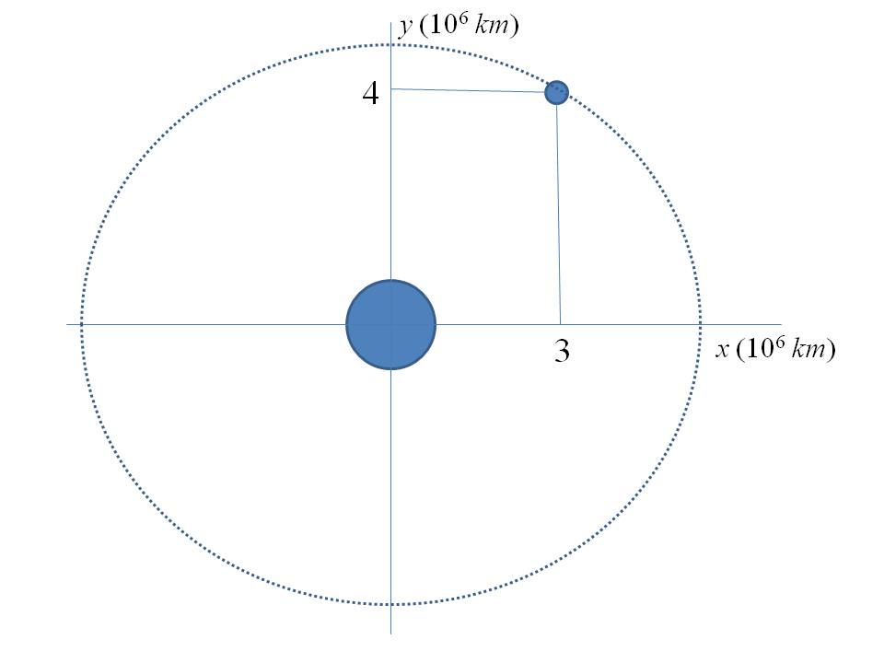

Because the orbit is circular, we may write a relationship involving the x and y coordinates of the planet.



**Problem Statement**: Find when the planet has coordinates *x* = 3,000,000 km and *y* = 4,000,000 km).

**Solution:** We will use implicit differentiation to find the derivative. We begin by taking the derivative of each side of the equation.





Now, we substitute the values of x and y into the expression for 



The slope of the tangent to the orbit at the point (3, 4) represents the value that one would expect to obtain by evaluating the derivative at the point. Visual inspection the figure reveals a slope with a value of approximately -3/4.

**Alternate Problem Statement**: Suppose that the orbit of the planet is elliptical. The equation governing the orbit is known to be:



Find when the planet has coordinates *x* = 8,000,000 km and *y* = 3,000,000 km.

Solution: We will use implicit differentiation to find 



Now, we substitute the values of x and y into the expression for 

